Final Project Design Phase
Computer Science - Week 11
Oct 3, 2026 - Version 0.0.4

For complete instructions and project ideas, refer to the assignment in Canvas. Specifically, review the final project requirements before you continue below. If you have not reviewed the project requirements in Canvas (you might have to go to the modules view and check the current or past week's content), you will not be able to properly complete the parts below. In addition, it may be helpful to review the information on this Drafter documentation page.

0) Project Planning and Preparation
Successful programmers spend time planning before they begin coding. After reviewing the project requirements, answer the following questions to help guide your design and development process.
- What concepts from class or previous assignments might help you complete this project? Which programming concepts (loops, conditionals, lists, classes, etc.) do you expect to use? What programming skills do you want to improve while completing this project?
Concepts from class that will help me complete this assignment will be loops, iterations, dataclasses, routes, pages, conditionals, etc. I want to improve my conditionals and my iterations during the project.

- Which parts of the project do you expect to be the easiest for you? The hardest? Why?
The easiest parts will be the loops, while the hardest will be the pages and drafter inputs.

- Even though you have not yet designed the final project, estimate which tasks will likely require the most time and effort? Which features or components should be implemented first?
The tasks that will take the most time and effort for me are the visuals on the page and making them look nice and functional. In my opinion, I should enter helper functions and most of the calculation functions first to make sure they work; then I can move on to the drafter portion.

- What distractions might interfere with your work and how will you minimize them? What resources will you need available while working? What questions, if any, do you still have about the assignment requirements?
Distractions could be texts or reminders for other things during my day, which I can minimize by using Do Not Disturb so I can focus on my project. The only resources I'll need are office hours if the LLM can't explain why something isn’t working; I don't have questions about the assignment requirements.

1) Site Diagram
Create a mock-up of your planned website. We suggest you make the mockup on paper, although you can also use software like PowerPoint or Slides to make a mockup. There is other design software that could also be used, but we strongly encourage you to keep it simple. Do not spend more than 15-30 minutes detailing the mock-up. Your goal should be to make a very quick and dirty diagram, to show that you have some kind of idea.

We recommend drawing each page as a rectangle, and laying out the text, buttons, and other components inside. Then, use arrows to indicate links between pages. Label each page the way you will name each function, and then put labels on the arrows to indicate what the button links. Also write down any parameters that should come into the pages.

In addition to the pages and routes, write down what fields your `State` will have, both their names and types. Think clearly about what data will need to be persistent across the entire website.

Add photo(s) or screenshot(s) of your website mock-up and labeled diagram on the next page.

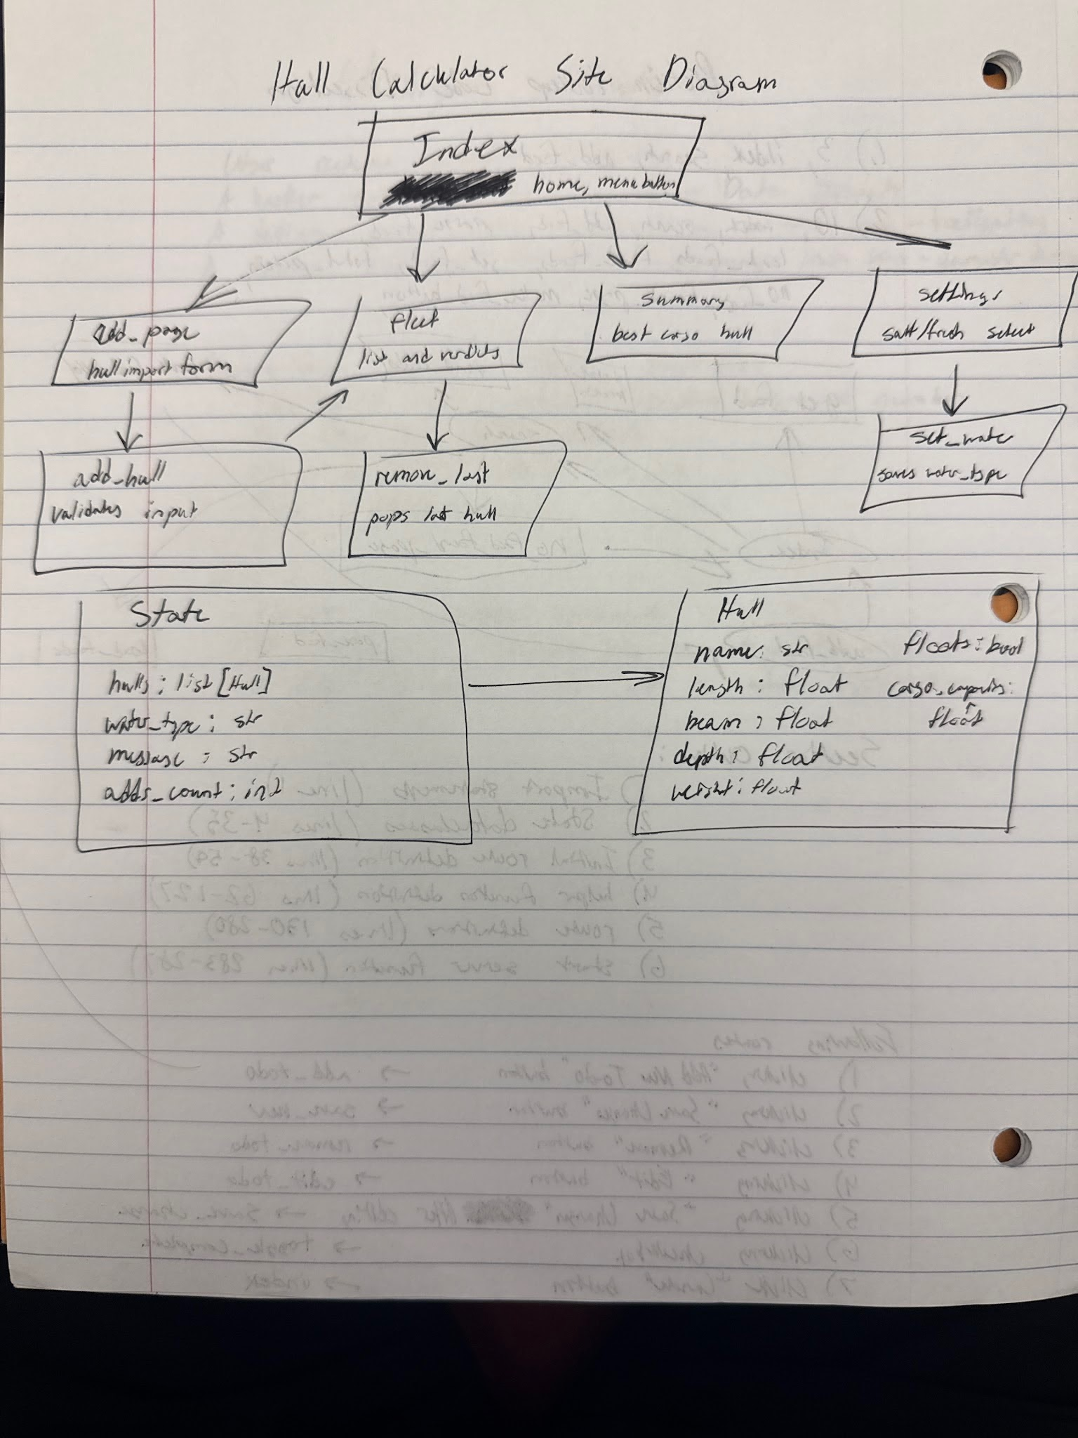
2) Implementing Requirements
This table should serve as a draft for how you will implement the requirements into your final project. You may change your ideas later on, but your final site must fulfill all the requirements.

Requirement | Implementation
Purpose/Functionality  A 1-2 sentence description of the purpose or functionality of your site | Create a useful, functional calculator that gives boaters meaningful information about their boat using the information the user provides. Ideally, this calculator will be used in the real world and prove the theory works.
State Dataclass Attributes  Minimum of 4 attributes, one of which must be a list/dict of instances of your second dataclass.  Briefly describe each attribute, its type, and how it will be meaningfully modified throughout the site. | hulls: list[Hull] starts empty, grows when the user adds a hull, and shrinks when one is removed. water_type: str is “Salt” or “Fresh”, changed on the settings page, and it affects the density used. message: str holds feedback like errors or “Added X”, and changes in almost every route. adds_count: int goes up with each added hull and is used to name the next default hull.
Second Dataclass  Your second dataclass, including its attributes, their types, and how they will be meaningfully modified (if they are modified) | Hull has name: str, length: float, beam: float, depth: float, weight: float, floats: bool, and cargo_capacity: float. It’s created once in the add route and is never edited afterward, only deleted.
Routes (minimum 7)  The names of your route functions | index, add_page, add_hull, fleet, remove_last, settings, set_water, summary
Pages (minimum 5)  A brief description of the pages in your site | Home with the menu and the latest message. Add Hull, a form for the measurements. My Hulls: a list of each verdict and cargo figure. Water Settings, where the user picks salt or fresh. Summary, which shows the best hull for cargo and the totals.
User Input (minimum 3)  Description of user input components (TextBox, TextArea, CheckBox, or SelectBox) and their purposes  For more information on these input types, see Drafter Documentation. | Four TextBoxes (name, length, beam, depth, weight, so five if you count them all) cover the hull data. A SelectBox on the settings page chooses salt or fresh water. You could add a CheckBox, such as “Use a 75% safe loading limit”.
If Statements (minimum 3)  Brief description of what will be evaluated in your if statements and how they will meaningfully change the logic of the site | Validation checks that all inputs are positive numbers, and if not, the route shows an error and doesn’t add a hull. The float check compares the hull’s weight against the maximum water it could displace and sets floats to True or False. A density lookup picks salt or fresh. Empty-list checks stop the Summary and remove routes from crashing.
Loop (minimum 1)  This loop must iterate over the list/dict of dataclass instances in your State attribute.  Description of this loop and why it is meaningful to the site | It goes through state.hulls to find the hull with the largest cargo_capacity, and to total the weights or count how many boats float. This is meaningful because the Summary page can’t work without it.

LLM Conversation
If you used an LLM in any part of this work, copy and paste every part of that conversation below. Otherwise, you may be given a zero for the assignment. Obviously, these words will not all be yours, and this is the exception to the requirement at the top of this assignment that all responses be in your own words. If you did not use an LLM to assist you in this assignment, simply say so below.
“Help me describe a State dataclass with a minimum of 4 attributes, a second dataclass, a minimum of 7 routes, a minimum of 5 Pages, a minimum of 3 user_inputs, a minimum of 3 if statements, and at least one loop; if necessary, add more to hit all ideas from my brainstormed thoughts.”

Here are rough notes for each row, to rewrite in your own words. They follow the float and cargo goal you described and keep the structure from the earlier design, so the code and the worksheet will agree. Change anything that isn’t what you actually plan to build.
Requirement | Notes to rewrite
State attributes (4) | hulls: list[Hull] starts empty, grows when the user adds a hull, and shrinks when one is removed. water_type: str is “Salt” or “Fresh”, changed on the settings page, and it affects the density used. message: str holds feedback like errors or “Added X”, and changes in almost every route. adds_count: int goes up with each added hull and is used to name the next default hull.
Second dataclass | Hull has name: str, length: float, beam: float, depth: float, weight: float, floats: bool, and cargo_capacity: float. It’s created once in the add route and is never edited afterward, only deleted.
Routes (8) | index, add_page, add_hull, fleet, remove_last, settings, set_water, summary
Pages (5) | Home with the menu and the latest message. Add Hull, a form for the measurements. My Hulls, the list with each verdict and cargo figure. Water Settings, where the user picks salt or fresh. Summary, which shows the best hull for cargo and the totals.
User input (5) | Four TextBoxes (name, length, beam, depth, weight, so five if you count them all) cover the hull data. A SelectBox on the settings page chooses salt or fresh water. You could add a CheckBox, such as “Use a 75% safe loading limit”.
If statements (3+) | Validation checks that all inputs are positive numbers, and if not, the route shows an error and doesn’t add a hull. The float check compares the hull’s weight against the maximum water it could displace and sets floats to True or False. A density lookup picks salt or fresh. Empty-list checks stop the Summary and remove routes from crashing.
Loop (1+) | It goes through state.hulls to find the hull with the largest cargo_capacity, and to total the weights or count how many float. This is meaningful because the Summary page can’t work without it.
The physics behind the notes, so you can check it makes sense to you. The maximum displacement is length × beam × depth × water density, which is the weight of water the hull could push aside if it were filled to the brim. If the hull’s own weight is less, it floats, and the difference is the cargo capacity. This treats the hull as a box. You should say that on the site, because real hulls are curved and carry less than a box would.
A couple of things to decide on your own. Is “other environments” in scope? Salt versus fresh is easy, but anything more (waves, temperature) is a stretch for this project. Also, do you want the safe loading checkbox? It gives you a third input type and makes the verdict more realistic, but it’s one more thing to explain.
When you’ve written your version, send it and I’ll check it against the spec, for example whether every state field is really modified in some route.

Final Submission
When you are finished, download this file as a Word Document (docx) and upload the file to the appropriate assignment on Canvas.

